PREFACE

The year end knocks on the door to pen down another Report for the year 2005-2007 of Shramajivi Mahila Samity.

I take the privilege and immense pleasure to flip over the pages of my not so fragile memory in retrospection of the previous year of SMS. We at SMS have been instrumental in exploring the potential at our behest towards the social development of the neglected sex i.e. the women in our society. The women in Singhbhum suffer from physical, psychological, financial, social, emotional, safety, security and health problems etc. The multi-dimensional women issues and problems have been successfully taken care of by virtue of relevant and meaningful intervention of SMS for the poor, downtrodden and underprivileged people.

The Annual Report 2006 – 2007 of SMS is an overview of the various development activities carried out during the year along with major achievements and specifics milestones achieved.

With the progress of time SMS has undertaken development initiatives to attain its focused objectives like:-
- Creating a conducive environment for the empowerment of poor, underprivileged, downtrodden, deprived tribal women.
- Promote the grass root level single women to identify their position in the society having a human touch.
- Ensure food security and livelihood development through advocacy of the Mahila Mandals, Gram Sabhas and linkage with govt. schemes and financial institutions.
- Attempts to create a space for indigenous people in the social setup and thereby bring them into the mainstream.

Thus SMS has been continuously striving to develop a people – oriented social setup with the constant endeavor and commitment of its staffs and field workers.

We would have been rendered helpless and handicapped without the moral, psychological and economic support and assistance of our donors, govt. officials and govt. and private institution. It is our continuous pursuit to make the relationship grow strong in future for the cause of the poor and needy people of Jharkhand.

Lastly, I on behalf of SMS appeal to all my readers and supporters to aspire and inspire us on our path to work for the cause of the poor and needy.

Purabi Paul
Secretary
Shramajivi Mahila Samity
Introduction

The year 2005 – 2007 has been a spectator to disturbance and turmoil for the state of Jharkhand witnessing political disturbances, nuances of MCC and the assassination of the MP of Jharkhand. Amidst all such hurdles SMS has made her way out to stick to its cause and work for the needy and poor.

With the fast pace of development in the globalized market, Jharkhand found a foothold after its separation from Bihar. SMS has been a pioneer in identifying the indigenous primitives status of the society and taken initiatives to assure their rightful place in the society with a humanitarian approach.

Focused on its overall objective of empowering the women in all facets of life SMS approached the day to day problems of the women be it atrocities, sexual abuse, Immoral trafficking, suppression of their basic human fundamental rights etc. they have been deprived of their existence in the domestic, social, political and economic life. With the active and dynamic support of SMS these grass-root level primitive women have been able to carve a niche, live with dignity and participate as equal to men in all spheres of life. However, in order to achieve this status for women of the Jharkhand region, SMS joined hands with many govt. and non - govt. bodies, women healed NGO’s, national and international forums beginning right from the centre unto the district level.

SMS has reached all the ramparts of the Jharkhand region and created awareness and consciousness among the people by virtue of campaigns, road shows, workshops, meetings, training programmes and seminars etc.
In the recent years SMS has catered and contributed to the women welfare pertaining to single women and their issues, reproductive, rights, child abuse, adolescent girls and their issues etc.
Over the span of ten years SMS has been a reckoning in the field of development of women addressing their numerous issues with commitment, sincerity, dedication and diligence.
It has earned as image of the driving force behind the all round upliftment of women and their status. It has successfully treaded the path to glory by virtue of its authentic and meaningful intervention.

Issues :-
SMS has always focused its action and strategies towards the following issues:-
- Upliftment and development of the indigenous primitive grass root tribe specially women and adolescents.
- Eradication of poverty through women participation and active involvement.
- Empowerment of women to improve the economic, social, political and domestic status of women.
- Promote and help them to develop skills related to their livelihood and sustainable development.
- Awareness and consciousness regarding reproductive health, physical and genetic diseases – their cause, effect and preventive measures, pregnancy, child birth etc.
- Upgrade and instill information on income generation techniques, micro finance and self finance.

Based upon its core issues SMS conducted various programmes and projects in the foregoing years of 2005 – 2007. A brief presentation of the various projects undertaken by SMS in 2005–2007 is being given hereunder:

SAMUNNATI PROJECT
Introduction

“SAMUNNATI” i.e. equal progress and development for all irrespective of caste, colour, creed, sex, status etc. through poverty alleviation and specially empowerment of women. The project started in April 2005 in the Sonua Block of West Singhbhum district covering 6 panchayats and 50 villages, out of a total of 60 villages.

Objectives of the Project :-
- To organize and build capabilities of the women for their social, economic and political empowerment.
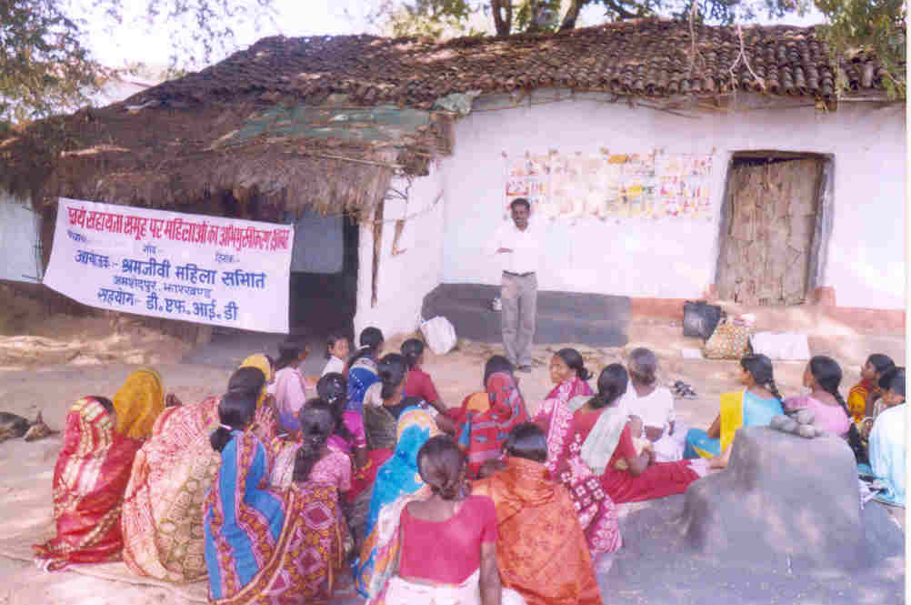
- Strengthen the economic condition of the poor and marginally poor families by skill development and group formation.

- To sensitize and mobilize the community for the realization of various entitlements, especially those related to food security.
- To enable and facilitate the various groups to access credit facilities.
- To sensitize the community on Gram Sabha, its role, rights and responsibilities.

- To emphasize and inculcate the habit of local self governance.

Issues Addressed :-
- Formation and strengthening of Mahila Mandals, SHG’s, CIG’s, Youth Clubs, Kishori Manch etc.
- Enable the women to be self-reliant and self dependent by empowerment and their participation in social, political and economic fronts.
- Advocacy for linkage to govt. schemes and entitlements.
- Enhance and promote women participation in the Gram Sabha.
- Ensure gender equality.
- Promote leadership building in women and men along with personality development.
- Ensure good community health.
- Emphasize the significance of local self governance.
- Ensure food security by formation of Grain Banks, Seed Bank and Gram Kosh etc.

Target Group:-
The target group includes women specially the oppressed and the suppressed class.

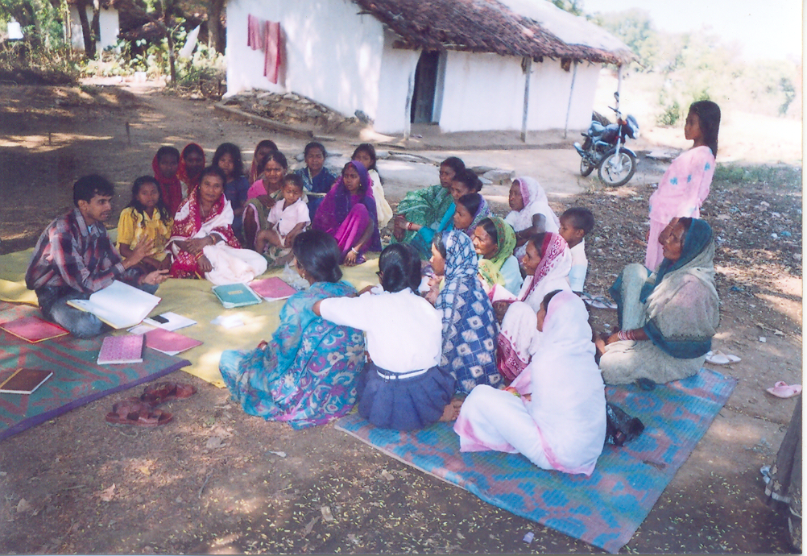
- Adolescent especially girls.
- Migrating families.
- Landless families.
- Women headed families.
- Artisans and other skilled people etc.
- BPL families, Annapurna and Antodaya families.
- Bidi Mazadoors.
- Poor SC, ST families etc.

Activities Undertaken:-
During the two years the project undertook the following activities with its focused objectives:-
- Every village has set up its Mahila Mandals and the members are profusely active and participating in all activities be it social, political and economic.
- SMS was instrumental in establishing Kishori groups in all villages and hence 55 such groups have been formed to cater to the welfare and interest of the Kishoris.
- 50 SHGs were formed having their own savings, process of linkage with banks and financial institutions has begun and are taking initiatives to identify and solve their own problems.
4. 25 CIG’s have been formed incorporating 440 members. The CIG’s have been imparted training in their respective skills so that their skills and capacity development is done which can cater to their alternative sources of income.
5. SMS has enabled and mobilized the community workers to make the villagers informed about the govt. schemes and help them access and establish linkage with
such facilities.
- Conduct Orientation camps for the Panchayat Level Women, Adolescent girls,
SHG’s, CIG’s etc to groom them, develop their potential and help them identify their problems and find solutions to them.
- health being one of the factors of poverty, regular health camps have been conducted with emphasis on immunization for children and would be mothers. Dai Training was also organized to ensure safe child birth.
- This was an important activity through out the project so that people were supplied information and awareness on there rights, roles and duties.
- PRA was conducted in 50 villages out of the sample of 65 villages falling in 6 panchayats. It was carried on for duration of three months beginning from July 15th 2005 to Sep 15th 2005through it was delayed due to the intervening acute rainy season and the harvesting season. Its objective was to collect village level findings and served as a fool to gather data so that it can be utilized for present and future plan of action.
- With the declaration of these two acts RTIA & NREGS the organization played an effective role in executing its responsibility on spreading awareness and consciousness regarding the aforesaid acts. The rural masses were infused with information on RTIA & NREGS and its significance in their everyday life.
- Regular weekly meeting of community workers, supervisors and project co-ordinator, monthly meetings presided over by the Project Director and the field supervisors was an important feature of the project. These regular meetings gave an insight on the progress of work, chalk out plan of action for future and share the experience during the course of the project. Besides reflection meeting was conducted at the end of every quarter to plan out follow up activities for the community workers and review the overall progress during the quarter.
- The organization was always a pioneer in ensuring food security and food distribution through out the community. It also established grain banks in villages and tolas to check hunger and alleviate poverty.

Achievements:-
The major achievements of the SAMUNNATI Project are :-
- PRA was conducted and successfully completed in 50 villages and the findings and data served as a gateway to the future activities and programme to be undertaken.
- The organization was able to achieve its goal while communicating about NREGS. The effective spread of knowledge about NREGS has made the people realize its utility for themselves and are demanding employment against it. Job Cards have been made in most of the villages.
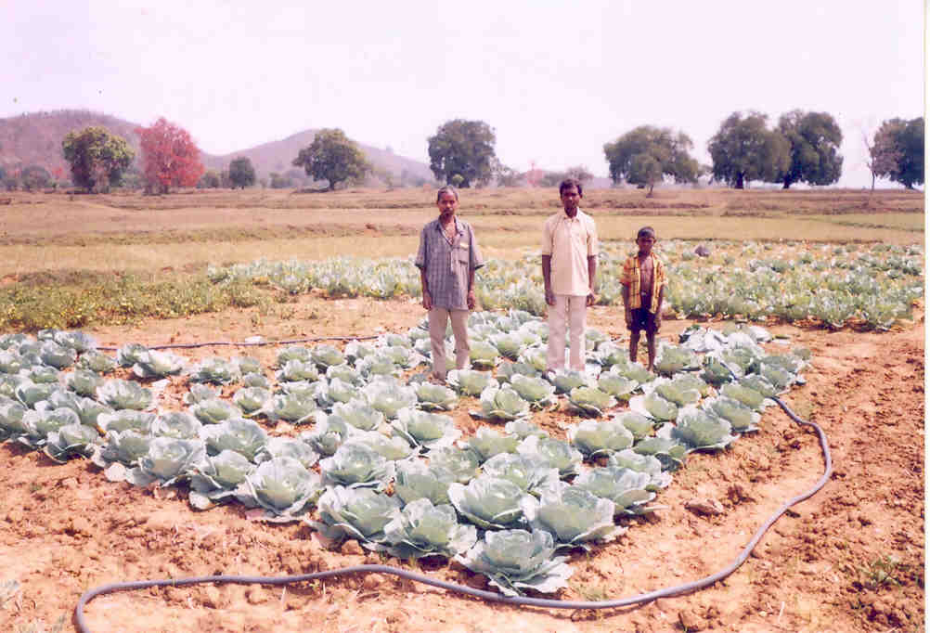
- RTIA was another govt. act in which rural people gained information and it is an achievement as they are already accessing information from the block office by virtue of RTIA.

- Formation of 55 Mahila Mandals, 50 SHG’s, 25 CIG’s and 55 Kishori clubs and their effective working mechanisms has infused the people with faith in group dynamics, team spirit and team work and assist them in overcoming individual attitude problems etc.
- Formation of grain banks and seed banks in certain (17) villages and tolas is an important achievement towards food security.
- Linkage with govt. programmes and awareness of the people to the various schemes like Annapurna Yojana, Antodaya Yojana, and Indira Awas etc. has provided relief to the actual beneficiaries and is an achievement in itself.
- Ten farmers were provided exposure cum training by the organization. They learnt mushroom and vermicompost cultivation and are utilizing this training where they are engaged in income generation activity and earning money. 104 women are involved in vegetable cultivation earning a profit of Rs. 600 – 700 per month. 287 women are indulged in growing cereals and pluses earning Rs. 300 – 350 per month.
- Skill development training imparted basically to the artisans has enhanced income generation activity. 25 artisans have been trained in bamboo product making and 20 artisans learnt by self motivation. Another 55 were trained in making rope products while 60 were skilled in forest produce collection and make money.
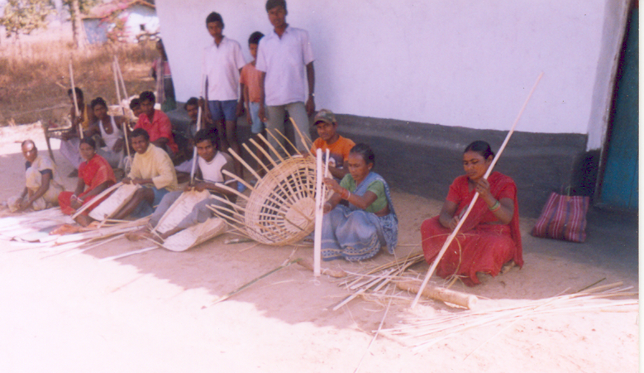

AN
ORGANIZATION FOR THE ENHANCED SINGLE WOMEN
TOWARD THEIR DESTINY
Ekal Nari Sashakti Sangathan, (ENSS)

Introduction:-

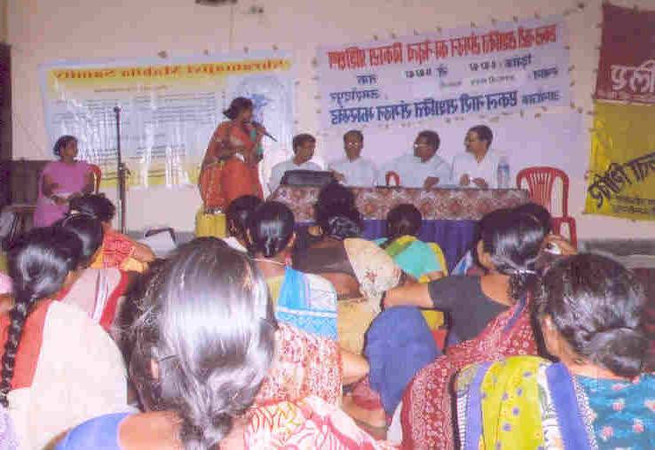
ENSS a project for the single women of Jharkhand was formally initiated on 7th July 2005 after SMS participation in convocation held at Rajasthan on 14th October 2004. This was commenced by SMS and to understand the present situation, problems, analyze the causes for being left alone and their status in the society. The project covered single women from 38 blocks of 18 districts in Jharkhand.
Objectives of the program:-

- Organize the single women of Jharkhand and strengthen them in all respect.
- To strengthen and mobilize the single women towards the realization of their rights existence and dignity.
- Prepare and groom them so that can overcome their forced weakness and fight for their secured and respectful life.
- Develop their leadership qualities so that they can themselves carve a place in the society.
- Prepare them towards lobbying so that they can advocate with the society and the govt. for establishing laws for the benefits and welfare of the Single women.
- To empower them to be self-reliant, self-dependent and self sustained.

Issues Address:-

- Establish the rights of the single women and for the betterment of situation.
- Ensure justice and dignity in the society for single women.
- Formation of association of the single women and strengthen it.
- Associate linkage of the single women association to govt. schemes like widow pension, red card etc.
- Ensure victimized women justice and safety through counseling and leading them to helpline, police, family courts and counselors.
- Abolish practices and nuisance like Witch Craft, Jadu Tona, Jhaand Phoonk, Dowry etc.
- Ensure land rights and property rights for the single women.
- Free the single women from domestic violence, dowry torture and bride burning etc.

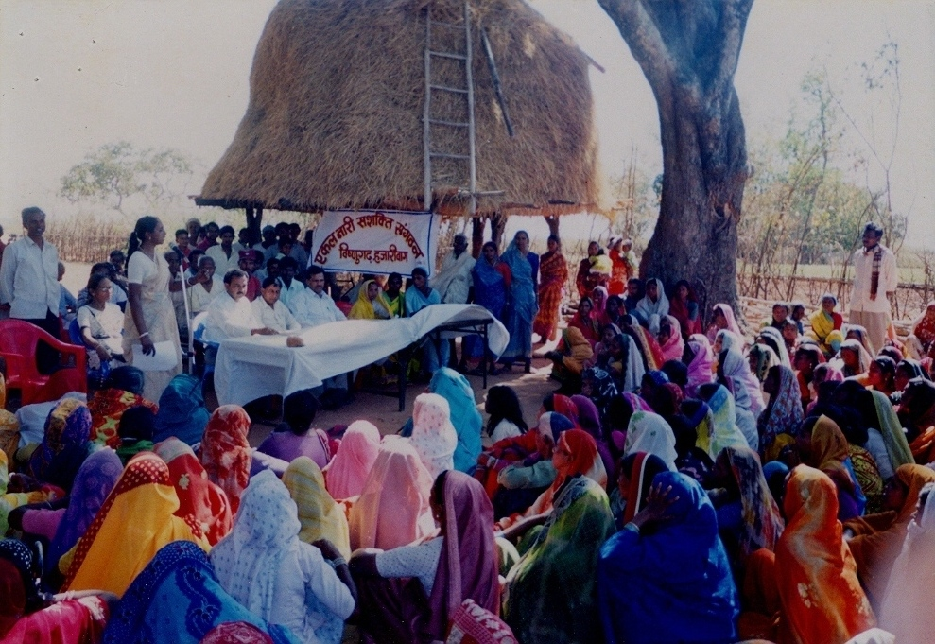
Target Group:-

The target group are -
- Widows.
- Unmarried single women.
- Divorced and legally separated single women.
- Destitute single women.
- Those women whose husband had Missing / Tressless / in jail.

Activities undertaken :-
- Formation of low income group single women association and strengthen the association.
- Constitution of state level committee to cater to the problems at the state level i.e. wider network.
- Conducted leadership training programme to develop their latent potential and overcome their shyness and earn respect, dignity and carve their own image and position.
- Orientation programme to develop skills that would endeavor these low income single women towards women empowerment so that they can have their individuality and identity restored.
- Advocacy and lobbying was an integral part of the activities through out the project so that they are updated with their basic, existence, fundamental and human rights. They were also imparted knowledge on their legal, social, land and property and political rights.
- The single women warily linked to govt. programmes for their benefits, like widow pension scheme, old age pension scheme, Antodaya Pension, Kanyadaan Scheme etc.
- Mass campaigns on abolishing social taboos like dowry, bride burning and witch craft, so that the conservative mental blockage is cleared and self development is sought for.
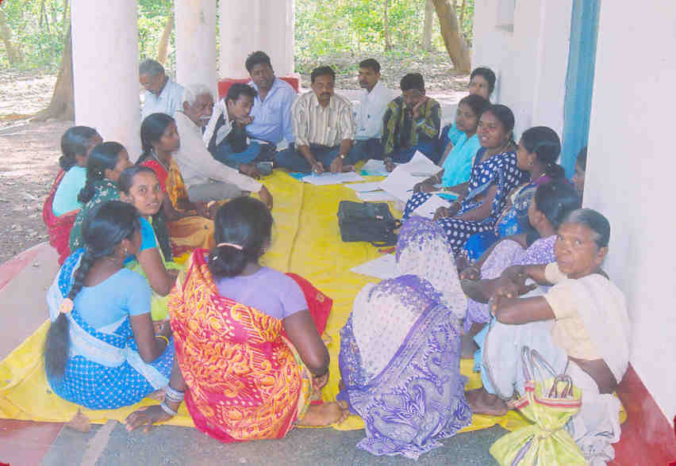
- Training programme on skill enhancement and capacity building so that they gain expertise in respective skills and become an earning member.
- Block committee was formed in 38 blocks to cater to the issues of the single women at the block level.
- Due to large number of members at the block level, a small committee of few members was formed called Counseling Committee after screening so that specific problems can be identified, counseled and solved.
- The projects served a fitting opportunity to study assess and conduct a detailed survey to find out the present status of the low income group single women of Jharkhand State.
- The organization was on its continuous drive to engage more and more single women as member of the association. Life long membership fee was decided as Rs. 10/- which will form the account of ENSS welfare.
- IEC material was prepared on a regular basis to generate awareness and information on the rights of single women and their status in the present society.
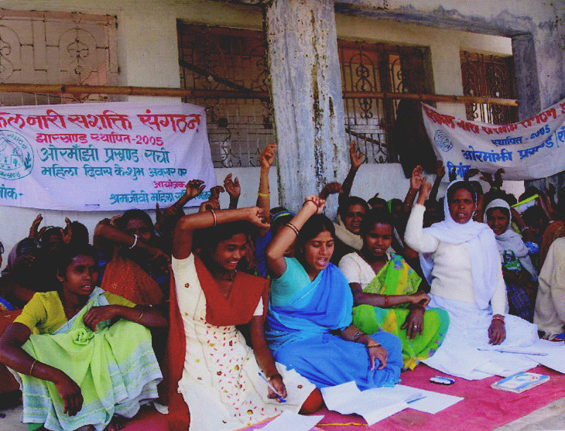
- SMS made its best effort to organize press conferences and conduct interactions with the press and the single women. The present society of single women have realized that print media and the press is an effective medium of expression.
- Another significant activity during the course of the project was ensuring land and property rights to these women which was deprived to them since ages.
- The projects achieved its main objective of identifying specific problems of the single women and subsequently assist them to seek legal relief and remedies.

Achievements:-
- The leadership programme conducted by SMS was a milestone where 303 single women were trained in leadership development that took place in March 2006.
- SMS was all the way ahead in procuring govt. scheme facilities for 588 women out of 7,000 single women and they were actually the genuine beneficiaries.
- Another major achievement was that the Ranchi Helpline identified 600 single women live cases within 10 months of the survey conducted during the project.
- Another positive outcome has been that the talk with the govt. has materialized and the govt. of Jharkhand will operate and act towards the health insurance for the people below the poverty line.
- Membership drive and the campaign carried out through the project to make the association of single women more powerful and widely acknowledged was another landmark achievement.
- Ensuring and granting of land and property rights to the down trodden and poor single women is another significant achievement. Thus such dreams would be realized.
- The formation of the counseling committee at the block level was a significant achievement as it was able to cater to specific issues since the no. of members was few in the committee and thus could deal with the problems effectively.

SANGHAMITRA PROJECT.

Introduction :-

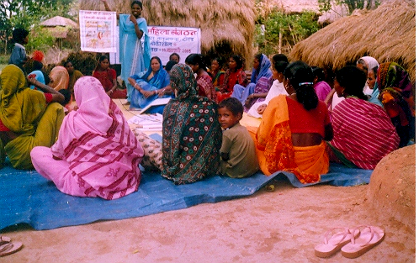
As the Sanghamitra Project commenced in November 2003 and has progressed for the past one year, this years ( April 2005 to Oct 2006 ) were more challenging and demanding. The emphasis of the project was women empowerment and reproductive health of the women and adolescent girls. The women empowerment centered around leadership development in such deprived class of women for their existence rights and political awareness on Panchayati Raj Institution and participation.

Objectives of the Project:-
- To strengthen the village level groups (Mahila Mandals, Adolescents girls groups, and SHGs ) to access their rights.
- To build knowledge and enhance the capacity of women and adolescents on leadership and its need in the present social set up.
- To create better environment building for health system with a focus on reproductive and sexual health of women and adolescent girls in the target area for the sensitization of PRI systems.
- To advocate for the better development through PRI system with maximum women participation.

Issues Addressed:-

- Strengthening of Mahila Mandals and Kishori groups.
- Leadership building in women.
- Emphasis on community health.
- Reproductive health of women and adolescent girls and sensitization of the community regarding it.
- Gender equality.
- unWomen participation in the Gram Sabha.
- Women violence ( Domestic and social )
- Legal rights.
- Advocacy for linkage of govt. scheme.
- Livelihood development.
- Awareness on PRI.

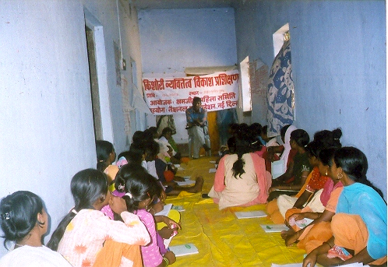
Target Group :-
- Deprived and oppressed women of the block.
- SC, ST and OBC communities.
- Adolescent girls.
- Sensitization of the male community.
- Women labourer.

- Strengthening of Mahila Mandals and Kishori Groups so that they can identify their own problems and tackle them accordingly at different levels.
- The leadership training programmes focused on developing decision making skills and adopt ideas to access their fundamental, social, domestic and political rights.
- A women federation comprising of local women from the 30 Mahila Mandals and 56 SHGs of the target areas to provide support and assistance to the village women for their better existence.
- Three staff development training programmes were conducted on topics like gender equality, environmental issues like soil conservation, water harvesting, nature, health and hygiene and balanced diet etc.
- Two days personality development training for the adolescent girls was held on 5th and 6th April 2006 to impart knowledge on their status, right etc and tackle their problems through personality development training.

- A rigorous three days training programme was organized for the R.M.P’s and Vaidyas in which the resource persons updated the participants on common ailment like fever, headache, body ache, gynecological problems, malaria, cough and cold etc. Other chronic ailments and their diagnosis and remedy was also discussed like Blood pressure, Tuberculoses and chicken pox etc. Women reproductive health and cycle was discussed at length with prenatal and post natal care. The Vaidyas were imparted knowledge on herbs and medicinal plans and their uses.
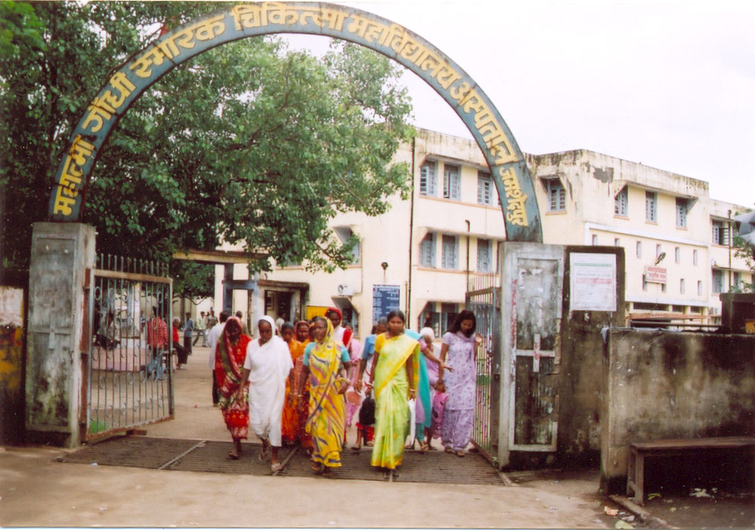
- The participants Dai’s who had received training earlier were subjected to an exposure trip to the local hospital Mahatma Gandhi Memorial Hospital, Jamshedpur where they were updated on the modern techniques of safe delivery, precautions to be taken during pregnancy and delivery etc.
- Campaigning on RTIA and NREGA was done through movement and march past by the women members of the Mahila Mandals Meetings were conducted to share information and impart knowledge among the male members of the community. Wall writings were done on awareness on Panchayati Raj Institution and self governance, Poster and Pamphlets were distributed among the community member’s village head and youth etc.

- The organization was able to establish linkage of the actual beneficiaries to the various govt. progammes. They were enabling to access the welfare schemes like widow pension, Indira Awas Yojana, Din Dayal Yojana, Antodaya and Annapurna Yojana and Kanyadan etc.

Achievement:-

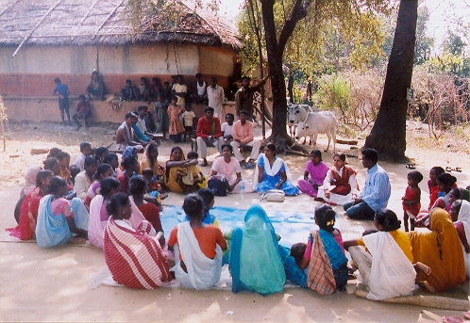
- Ngu?i ch?t s?ng l?i http://gaigoitanbinh.xlphp.net/
- 80% i.e. 800 members of the Mahila Mandals ensure regular presence in the meetings and are capable of solving their own problems.
- 549 women and 928 adolescent girls are aware of their reproductive rights.
- 183 women and 232 adolescent girls are able to access their rights.
- 693 women have acquired information and knowledge on PRI and its functioning.
- 48 poor and marginal families have been linked to govt. provision schemes and are able to access their benefits.

SAATHI
Introduction:
As the name suggest “Saathi” means togetherness. Rather “Saathi” is an extension of the previous project Sanghamitra in the Dumaria Block. It was observed that working over three years in the Sanghamitra project surfaced positive attitude in the community health, local self governance, leadership and personality development in the women and adolescent girls. Rather the limitation of the Sanghamitra project caters to the emergence of the aforesaid project SAATHI in the Dumuria Block. The project caters to community health by developing resources on health as social motivators or the “Saathis” to serve the community. The concept uprooted through National Rural health mission and its objective of “Health for all”.
Objectives of the project :-
- To enable the marginal poorest of the poor families access medical and health care facilities.
- Develop community health motivators who will function as “SAATHI”.
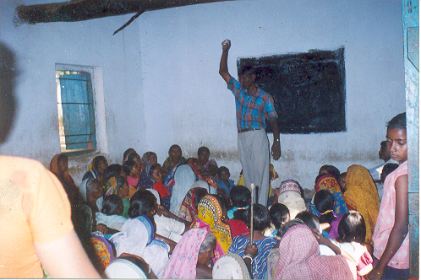
- To sensitize the community (especially men and other stake holders about the importance of community health.
- To enable the capacity building of the women village leader for rendering health services in their surrounding area.
- To improve immunization for children (0-5) and safe delivery to address mother and child mortality.
- To enhance women’s leadership through the federation for regularizing govt. health care delivery system and access of programme through the panchayats.
- To sensitize the community on gender issues., like - to motivate, especially the girl children for going to school.., address gender based violence and improve gender role i.e. involvement and support on gender aspects.

Issues :-
- The basic health condition as well as the understanding on the “Health” of the community that is poor.
- Poor health seeking behavior especially for the girls, adolescents and women.
- Poor safe practices vis a vis mother child health care.
- Families residing close to the forest and hilly areas, where there is inaccessibility of important facilities, have significantly high mortality and morbidity rates of mother and child.
- Lack of integration of sanitation, hygiene nutrition and drinking water sues.
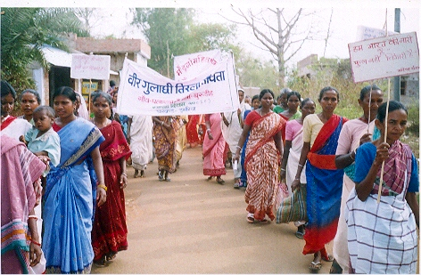
- Due to poor facilities and services provided by the public health system has an effect on the level of community participation.
- Lack of proper facility of institutional delivery. As a result, under performance of the health system and weak institutional frame work leads to poor socio-economic factors.
Target Group :-
- Women at hamlets level.
- Mother and new born child.
- Dai’s / Resident Medical Practitioners.
- Community ( men both elderly and the young men and other stake holders).
- Gram Sabha members.
- Adolescent girls (12+ age).
Activities :-
The activities undertaken under the “Saathi” project as a new approach to basic community and material health in the vulnerable areas of the block integrating health and leadership as follows:-
- Regular meetings have been organized and conducted in 19 villages out of 24 villages under the project area. The meetings with the Gram Pradhans and the community focused on improving the community health and their participation was sought for in the project implementation.
- The visit of BDO Dumuria Block Mr Lalchand Dadel was a milestone so far as proper implementation of the govt. schemes is concerned. The Block Education officer was uncontacted and apprised of the significance of adolescent girls’ education and carrier and his assistance was sought for their admission and re-admission. The local police station was contacted and sincere co-operation was sought for in light of women violence and torture cases.
- Contact was established with PHC doctor Dr. Shasibhusan Singh and ideas were exchanged on health of the community. The ANMs, Anganwari Sewikas and school teachers were brought together under one forum and directed to share knowledge with the people on community health at their respective levels.
- The field staff members got in touch with the SHG and Mahila Mandal members and sought their co-operation in identification of the genuine candidates to be appointed as community health motivators or “Saathis” in their respective areas and villages. Altogether 23 Saathis were appointed for different villages to work for the safeguard of community health.
- Immunization of the mothers and new born child was done in different panchayats aggregating 1151 children and 35 pregnant women.
- The women village leaders or Saathis were trained and oriented to disseminate information from the households pertaining to family details, status, livelihood, health etc. so that the information can be used for rendering health services in the specific areas with the help of these “Saathis”
- In four Panchayats were formed the community awareness on gender equality is being done to address the old mind set of the elderly males in the family. Sensitization at the community level that the health is not the responsibility of the women alone but of the family and society as a whole besides issues like equity men and women, gender roles and participation etc.

Achievements:-
- The major break through has been that the women have learnt and realized that their role and participation outside the domestic front is more significant and this consciousness is remarkable.
- The women have gained understanding about their reproductive and political rights and are capable of taking up their own issues to the Gram Sabha and local government through Mahila Mandal forums.
- Appointment of 23 community health motivators or Saathis has been an achievement for the health awareness in the community.

SHG Linkage and Income Generation Activity

Background :-

Since the transition of society the status of women has undergone a sea change. Though they are still in the age of liberalization and freedom from the male dominance especially in the economic front, their dignity and economic progress has still a long way to go. For economic empowerment of women they should possess control over money and wealth, access over resources etc. Hence Self Help Group formation was a must to have positive impact and hence it was thought upon.
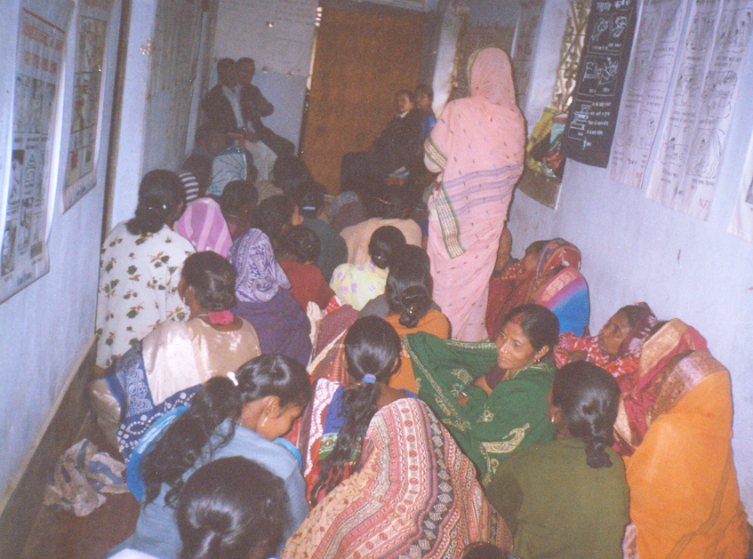
Objectives :-
- 50 cohesive women self help groups shall be functional.
- Self managed savings attitude development.
- Collective money can help in self and family development.
- Saving and credit self help groups of women shall be socially and economically empowered.
- The participants will have significantly increased involvement in key house hold decision making.

Target Groups :-
- Poor, down trodden families.
- BPL families.
- Women
- ST / SC Women
Working Strategy :-
The women federation formed of poor and marginalized women should be trained in savings and sustainable micro–credit projects and economically empowered to expand micro-credit business and learn to control their funds and savings.

Activities :-
- Formation of 50 cohesive women self help groups in Dumuria Block and is function.
- Training of SHG members on saving and effectiveness on achieving self sufficiency.
- Empower the SHG members to be socially and economically independent and develop decision making ability at the household and organizational level.
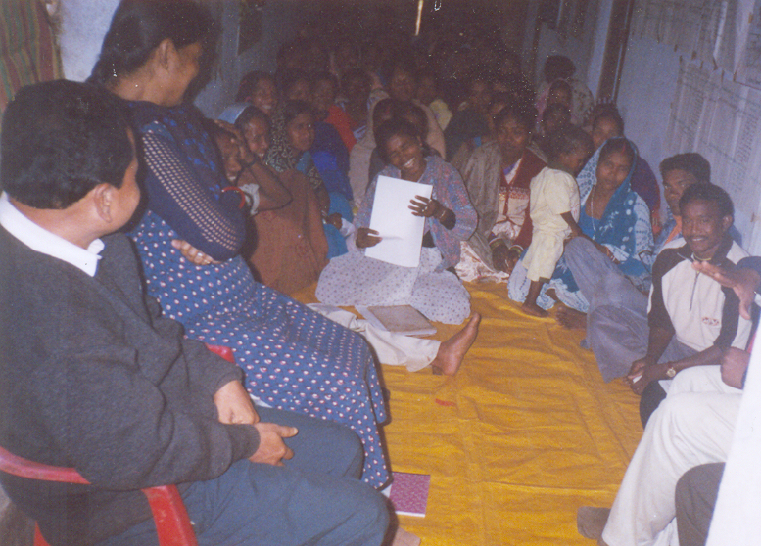

Achievements :-
- Formation of 50 SHGs of poor and marginalized women in Dumuria.
- 50 SHG learnt to self manage saving and credit at the micro level.
- 50% of the members of the SHG acknowledge increased mobility and decision making capacity.
- 25% of the members pursued new micro enterprises after the project intervention.

REALIZATION OF HUMAN RIGHTS AND FUNDAMENTAL FREEDOM FOR WOMEN IS ESSENTIAL TO REDUCE THE VULNERABILITY OF THE SOCIETY

Background:-
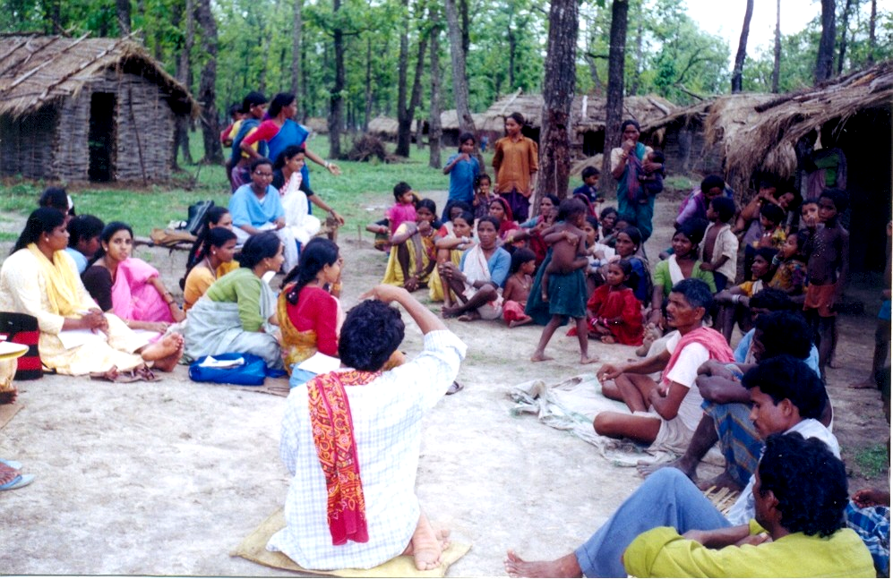
The present status of affairs in the state of Jharkhand is a witness to political turmoil, disdain policies and deprivation of human rights. This has profusely enabled women violence, atrocities, sexual abuses, single women problems and many more women related problems and the tribal women are the most vulnerable elements. Hence SMS attempted a small approach to strengthen the tribal women of Jharkhand to exercise their rights and gain control and access over their basic human rights, existence rights and fundamental right to live with peace and dignity.

Objectives :-
- Create awareness among tribal women pertaining to reproductive rights and local self governance.
- Create environment in such a manner that women can access these two rights.
- To begin women movement and women revolution in the project area to establish the aforesaid rights.
Issues :-
- Apprise and inform the women regarding their rights and liberties.
- Update them with the laws governing the tribal rural women.
- Training of the tribal women regarding Panchayati Raj Institution and its impact on the local governance system.
- Enable participation of women in the Gram Sabha and decisive bodies like “Mata Samity”, “Siksha Samity”, “Migrani Samity” and “Ban Rakshak Samity”.
- Promote community awareness on women reproductive rights.
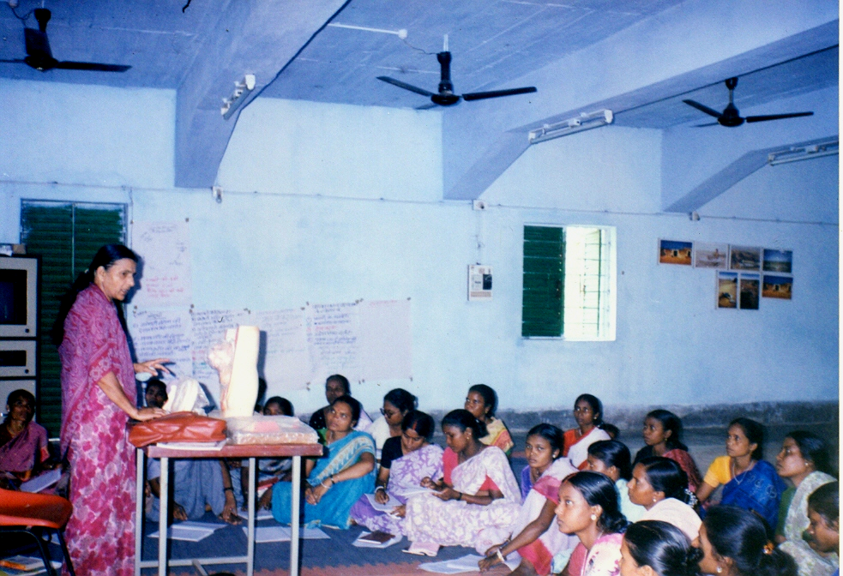
- Promote the support and care of the male fraternity in the safeguard of reproductive rights of the women.
- Sensitize the male community, society and the govt. health personnel on reproductive health of women and immunization of women and children.

Target Groups :-

- Tribal women.
- Adolescent girls.
- Traditional village head.
- Gram Sabha members.
- Dais, A.N.M’s, TBA’s etc.
- Anganwari Sewikas.
- RMP’s.
- Youth Clubs.

Activities :-
- Organizing the tribal women at the village level to form committees and address the women issues and problems from that platform.
- Conduct meetings of adolescent girls after organizing them into groups. The meetings enable the girls to acquire knowledge about women rights pertaining to reproductive rights and political rights.
- Traditional village heads who refuse to change their mindset needed motivation and hence orientation of such village heads was undertaken to update them with women rights, laws governing women, role of women in the Gram Sabha and local self governance.
- An orientation camp for the women was organized to enhance their participation in the governance to enhance their participation in the governance system and impart knowledge on the institution of Panchayati Raj and their political rights.
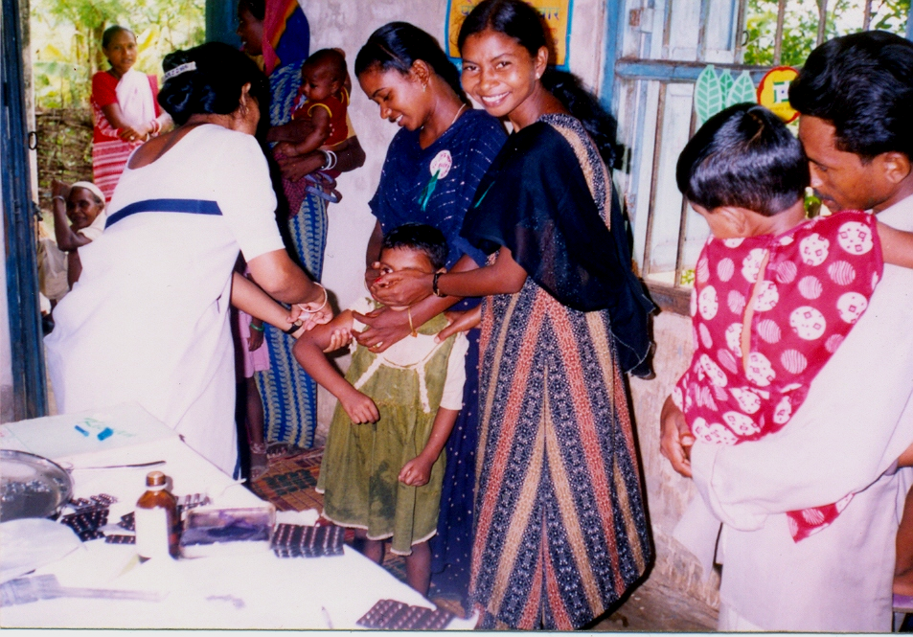
- Health camps organized in two panchayats of the target area was the right platform to generate knowledge and sensitize the male community regarding reproductive health of the women and adolescent girls.
- Interactions with the specialized personnel ensure timely and regular checkups of the various reproductive diseases and general health problems besides pregnancies safe deliveries etc.

Achievements:-
- The orientation camps of the village heads enabled enhanced participation of the women in the Gram Sabha.
- Decision making capacity of the women increased and their involvement in political area enhanced.
- 158 males underwent vasectomy which reflects concern of women’s reproductive health.
- 304 patients present at the health camp were referred for checkup and treatment.
- Social standing of the women has improved.

FOOD RIGHT AS HUMAN RIGHT.
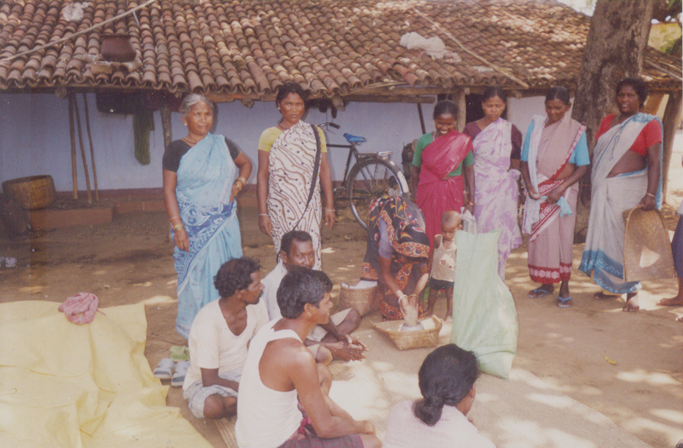
Right to food and freedom of movement are so interlinked that deprivation of either must inevitably damage that fabric of the other. The freedom to agitate for food and sustenance to fight for one’s liberties are concomitant. Most fundamental social & economic rights like right to livelihood, shelter food and access to water have failed to work for the poor in the past because of the feeble nature of their legal obligation. Economic rights would not only include a “right to work” or “right to eat” but would also include a right against exploitation.
The present situation must cause concern not only to us but also to all human right activists. Economic growth is not sustainable without a commitment to employment generation and human development that may reduce poverty. Hence, it has become very much essential to establish right to food & to have proper security of food for every individual.

GOAL: Women’s empowerment to enable food security and reduce poverty in the area.

OBJECTIVE

- To organize and build capabilities of women & community to reduce hunger & access towards food security.
- By forming groups like SHGs, common interest groups (artisan), farmer club to strengthen the economic condition of women and marginalized families through various skill development programs.
- To sensitizes women & community on PRI (Gram Sabha) its rights, roles and responsibilities on food security & poverty alleviation
- To mobilize community for their fundamental, civil and judicial rights & entitlements especially those related to food security.

This programme was formally launched in January 2007 hence the theme of food security got all was focused upon. Basically awareness generation among the people was taken up. It was publicized that food right is a human right. Women participation and involvement is ensured. The women SHG’s and Mahila Mandals that were formed were assigned the task of mobilizing the community in ensuring food for all. The community sensitization that all human beings need food to exist and hence acquire it by all means. Further the 9 points programme of the govt. to fight hunger should be accessible to these people. They should be linked to the public distribution system to fight hunger. The recent NREGA launched in the village should provide 100 days employment to all such people including women which can generate income and thus ensure food security. The other provision of non employment allowance should be demanded as laid down in the provision of the Act so that poverty does not strike. Basically only these areas have been torched upon.

FUTURE PLAN OF SMS

The organization has grown up gradually with the flow of time and envisages a future plan as well. SMS plans to establish an equitable society by integrating the grassroot level indigenous people into the mainstream of the society. It plans to foster positive attitude and positive thought among the deprived and downtrodden specially women and economically weak inhabitants of the rural areas. It plans to sensitize the community towards socio – economic sustainable development, women empowerment, fight for the human right of the single women, disabled, tribal, economically suppressed and downtrodden sections of the society.

However other associated issues on which the organization plans to focus are fundamental freedom of human beings and curb evils like atrocities, sexual abuses, domestic violence superstitions etc. It understands that there is a need to contribute to economic development by skill development and capacity building, venture alternative livelihood sources, improve rural governance system and propagate Panchayati Raj institution.

Lastly SMS is open and wishes to provide its service and support for the good and noble cause of the society.

Women Elected Treasurer in Gram Sabha at Sonua Block,
In West Singhbhum, Jharkhand.

Recently govt. of Jharkhand has declared that every Gram Sabha would get Rs 50,000 by the state govt. for the development of their village. As per the declaration the signatory right would remain with Treasurer & Secretary. After the declaration every Gram Sabha selected Treasurer among the members.
Sonua Block which is selected in the western part of Singhbhum district also had the election for the treasurer in all the Gram Sabha. Mostly, the treasurer are elected person from the village. In Kulundu village of Segasai Panchayat, a Mahila Mandal called “Yashoda Mahila Mandal” has been created by SMS. Here Mrs. Chanda Mani Bankira has been elected as the treasurer of Gram Sabha.
On 20th march 2006 the Gram Sabha meeting has been arranged for the election of the treasurer. There were around 38 women in the Mahila Mandal and a huge no of men were present Mrs. Chanda Mani Bankira contested from the village Kulundu . She defeated her rival and was accepted for the post of treasurer. Finally many men also supported Chanda Mani for her leadership quality.
From the very beginning Chanda Mani was the treasurer of the Gram Sabha. By that time Gram Sabha was not very effective. After the declaration of the post of Treasurer in the Gram Sabha and allotment of Rs. 50,000 for the development of the village. There became a huge fight in all the 4 corners for the post of treasurer. At this peak moment getting victory over the post of Treasurer by Chanda Mani express the increasing leadership quality of the today’s women. Even other women gained their confidence and every body in the village got assured that the receiving fund will be used in proper way for the development purpose.
A similar example can be cited from Gajpur village of Sonua Block. Shramajivi Mahila Samity has created “Indira Gandhi Mahila Mandal” in Gajpur village. Mrs. Kulawati Devi contested for the post of Treasurer from this village. But she was defeated by her contestant as some male of the village did not support her. Even though Kulawati Devi was not accepted for the post of Treasurer in the Gram Sabha, but her inner qualities, her leadership instinct and her courage created her fame throughout the village. And Gram Sabha has re elected her as the Vice Treasurer, so that through her qualities she can strengthen the Gram Sabha.
Both the case studies show the increased leadership qualities of the women. Mahila Mandal created by SMS has developed a new scenario for leadership quality among the women of this region.

A story of Alladi Soren

The name of Alladi Soren has become very popular in the Bakrakocha village of Asthakowali Panchayat. The village Bakrakocha is 30 km away from the Block headquarter of Dumuria. The village is surrounded by the forest in all the three sides. Alladi was born in the village Bangarkola. She is married to Buden Soren of Bakrakocha village around 10 years ago. She has a son of 7 years.
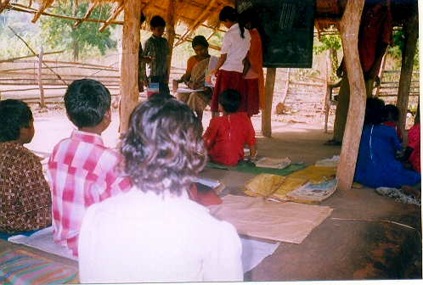

Village Rahargora is adjoined to Bakrakocha village. In this village an EGS school has been opened by Jharkhand Education Project (JEP) to educate the village children. There 56 children in the School. Gram Siksha Samity has also been formed by the villagers. Under JEP it has been announced in Siksha Samity to depute a teacher to accompany the children in the school. But unfortunately, in both the villages there were no educated person fit for teaching. Alladi was the only non matric among them.

In the meeting of villagers & Gram Siksha Samity, Alladi Soren was respectfully selected for the post of teacher. The Education Department was informed accordingly. On August 2002, the Education Department summoned Alladi Soren to impart her services in the school. The permission was given in written from the Education Department.

Alladi Soren spent her one year very nicely with the children. But, in 2004 suddenly without any reason she was prevented from rendering her services by B.R.C. When she enquired at the office they could not clear the matter. Sometimes they gave reason about her being non-matric or presence of less pupil at school or sometimes they demanded for Rs. 3000/-.

She also went to District Education Office and to the Jharkhand Education Office, but everything was in vain. There was no such report lodged in those offices. After few days she joined the teachers training organized by Jharkhand Educational Project. In 2005, The Education Department ordered the Gram Siksha Samity to reemployed Alladi in the school. From Jan’ 2005 to Dec’ 2005 she regularly gave her services in the school but was exempted from her salary.

She gave a written application for pursuing her salary in the BRC but the official demanded Rs. 3000/- instead. When denied, Alladi was exempted from her salary. She further lodged an application letter to the District Education Office. At this, the BRC official restricted her from delivering her service in the school as a teacher.

Gram Siksha Samity also supported her but still she was not given her salary. On Aug 2005 Alladi lodge her complain on the basis of Human Rights. On 18th of Feb 2006, she reported this to the Home Minister of the state Mr. Sudesh Kr. Mahato. He was thoroughly quenching the thirst of the public queries in a programme “Prashasan Aapke Dwar Par”. Alladi also documented her problem both verbally & in writing to the Home Minister. The Education Department was ordered to deliver the teacher’s salary at her residence within two days. Yet Alladi did not receive her pay. Without the salary she continued teaching in the school.

The teacher strongly agitated on her point that she will continue her fight. At present every body is with her. Women of SHG, Gram Pradhan, G.S.S. & villagers are also supporting her. Education Department has assured her to resume her with the salary within April 2006. Her verdict is if she is not reimbursed with her salary within this period she will knock the door of the court & get her right.
SMS THOUGHT

Community Food Security.

The indicator of the development of a community and/or a society is revealed and ensured with the availability of food, cloths and shelter for everyone. Every individual of the community should necessarily get optimum quantity of secured food. Food security can be ensured essentially only if the whole population gets two square meals a day irrespective of the gender (male organized female) differentiation and secure the optimum quantity of grains during adverse times.

India is a developing country, and is ahead in producing food grains in comparison to many countries. Nowadays, food grains are being exported to other countries as well. No individual in India shall be hungry if the ratio of food grain production and population is compared. But the reality is that the major chunk of the population is deprived of food and hence dying of hunger in most of the states of which Jharkhand is also a part. Going into the depth of the subject one can realize that the factors like low wages, the scarcely available resources in the state not being utilized optimally. For the development of the state and its inhabitants, regular affect of natural calamities like drought, flood, people’s migration at other states for better avenues, non-utilization of scientific and technical knowledge for the development purpose, lack of education and awareness etc. leads to more probability of food insecurity.

The government has been making attempts and running various schemes and programmes to ensure food security. The recent order of the Supreme Court has provoked the govt. to begin a nine-point programme for ensuring food security so that the deprived class is provided with two square meals a day and thereby ensure food for all. The BPL families are being given 100 days employment for enabling them to work so that they get wages in lieu of work and thereby food security. However all said and done, every individual is actually not receiving food security cannot be ascertained for all inspite of all programmes and schemes laid down at our behest.

The preservation of secured food should begin with every family in each and every village. The community organizations like the Gram Sabha, community based organizations like Mahila Mandals, Youth Clubs; Kissan Clubs etc. have a significant role to play so far as food security is concerned. Every village and the participation of its community can enable storage of food grains, storage of seeds of high quality and formation of village fund. This can be done by the active participation and suggestive approach of every individual. The approach should be irrespective of caste, creed, sex, faith, religion, feudal landlords, landless labors etc, and then only the cherished dream of Seed Bank, Grain Bank and Gram Kosh can be ascertained.

Preliminary ground work preparation is to be done for the formation of Grain banks in every village right at the grass root level. The disputes and discrimination that is so rampant in the villages should be abolished. The land – its types, nature and quality in details should be clubbed together in details. The land pattern should be studied in details. The land classification should be done based on its pattern such as agricultural and non-agricultural land. Further classification should be done as irrigated and un-irrigated land, besides upland, barren land and waste land. In addition to this, these are low lying lands (Bahaal), middle level lands (Kanali) and uplands (Taand) should also be ascertained.

Apart from the land details and its classification, crops should also be studied in details. The present status of production of crops whether they are food crops, cash crops, horticulture plants, fruit orchards, and medicinal plants or organized social forestry products should be analyzed. However this can be done as follows-
- Status of present crop production should be done and crop varieties should be identified.
- Storage of food grains and seed banks can be done properly only if the storage system is ascertained- its structure and container for storage is previously-decided.
- Further stock place and stock area should be finalized and ensured.
- Ascertain the appropriate time of storage of food grains and seeds.
- Ascertain to what extent and quantity each family can preserve food grains.
- Formulate a comprehensive system such as record maintenance, rules and procedure, storage and maintenance system for the preservation of food grains.
- Ascertain the optimum preservation time and distribution time of food grains and seeds.
- Ascertain the duration as to what extent the food grains and seeds can be stored without spoiling them.
- Ensure proper and effective linkage of Seed Bank and Grain Banks with the grain, seed & manure distribution done by the government so that they are strengthened. The Gram Sabha has a major role to play in this area.

The Gram Sabha can adopt the following steps to improve the status of Seed Bank and Grain Banks-
- The grain banks and Seed banks are in existence in the villages since long. But they are either closed down, or perished due to the weakness and malpractices of the community.
- The Grain Banks and Seed Banks can be made more easily viable and feasible if a team of people involve themselves and work seriously for the sustenance and existence of them
- The Gram Sabha should prioritize and ensure the availability of food for all the individual families in their villages.
- The Gram Sabha should ensure the serious involvement and participation of women in all areas such as food storage, food preservation and food security.
- The mobilization and functioning of the Grain Banks and Seed Banks should be such that the BPL families, poor and deprived class, disabled & handicapped, single women, landless families and senior citizens and all the other weaker sections of the society are given priority in food distribution system as the deprivation causes death to a greater extent in the aforesaid target groups.
- The stability and sustenance of the Grain Banks and Seed Banks is in continuity should be ensured by the Gram Sabha and in order to achieve this, the Gram Sabha should have proper linkage and communication with the government, social representatives, Panchayati Raj Institutions and the community based organizations.
- The Gram Sabha should prepare a detailed family list based on economic status along with the linking system and distribution of seeds and food grains.

However certain measures should be adopted to improve the functioning of the Grain Banks and Seed Banks and thereby maintain its sustainability-

- Prepare a list of the left out barren land and waste land. These unutilized lands can be prepared in order to improve their utility.
- Formulate a plan to use the barren and waste land and its purpose to enhance its productivity so that returns are good. Chakbandi can be done.
- The rural banks and agriculture promotion banks should be contacted and assistance asked to promote and enhance such fertile lands for some useful purposes.
- The entire system and process should be converged with the government machinery for sustenance and self reliability e.g.- Assistance from the land development department of the government can be asked to convert upland into yielding land.
- Proper distribution system of seeds and manure should be adopted.
- Enhance the use of Kissan credit cards.
- Easy loaning system should be there with the rural banks and agriculture promotion banks etc.
- The upland should be utilized effectively if greenery is maintained through cultivation and planting trees.
- Pressure creation, integrated government aids, community support and private assisted bodies for maintaining the water conservation system.
- Promote improved variety animal breeding.
- Promote kitchen garden in every household in the backyard.
- Promote protection of forest and preserving medicinal plants, forest produce and horticulture.

Tomorrow Citizen

Introductions - Adolescent holds the coming future in their hand; hence their progress is dynamically necessary. The total society has to vest their work for the betterment of this class. Political will, inter sartorial Co-ordination, community participation, NGO’s community and deep involvement of the adolescent themselves in the development process is essential. To meet the needs of the adolescent as a distinct group, their voices need to be heard, energies channelised and their dream to be fulfilled for a better tomorrow.
Aim - The prime aim of this Programme is to uplift the Adolescent groups through societal & behavioral changes.
Objective - To furnish the goal of the Programme certain objectives had been lined out.
- To develop the overall personality of the Adolescent s so that they can fully access the adolescent rights.
- To create opportunities and challenging platform for these youngsters.
- To establish an environment within the community so that the change is conceived.
Strategy - To adopt the scenario of social & economical transformation in reality it is very much essential to have strategic investment for the Adolescent.
- In-house activities as well as outside phenomena are addressed to create a platform for collective approach.
- Capacity building and skill development amongst the adolescent groups.
- Close interaction and counseling by parents, mentors and prominent figures of the villages.
Intervention based for the development of Adolescent.
Some of the best work done by SMS in the grass root programme is:-
- Formation of village Adolescent Resource Centers.
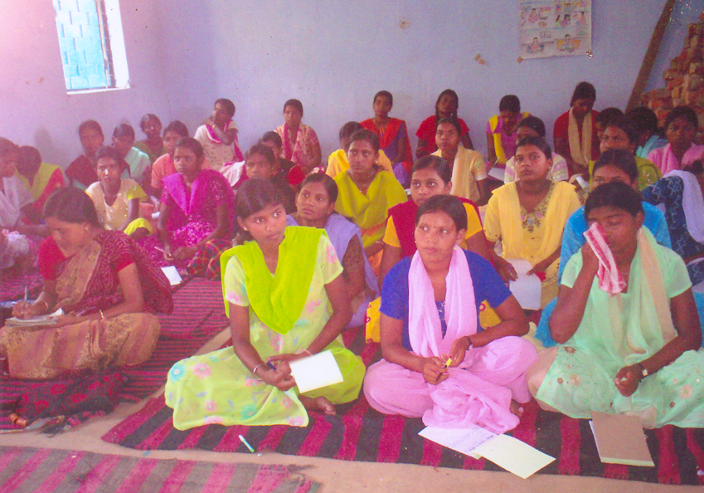
- Exposing to the inert talent of the Adolescent through workshop mode.
- Awareness generation in overall aspects of health, education, recreation etc.
- Conventional & unconventional skill building for the Adolescents.
- Energizing the adolescent with sportsman spirit.
- Developing adolescent communication system.
- Sensitizing the Gram Sabha, community, family member and parents for child marriage & early pregnancy.
Tools - Certain tools implemented to run the programme can be counted down….
- IEC/communication material on overall aspect.
- Workshop to surface out the hidden talent of the Adolescent.
- Legal knowledge & adolescent rights to be accessed.
- Exposure visit of adolescent to the block, hospitals, polling booth etc.
- Free check-ups and health camps for disbursing knowledge to the Adolescents.
SMS Views - Our 4-5 years field experience reflects that if the two folds process of in & out housing activities are shared amongst the Adolescent within the age group of (10-11) they chalked out the following.
- Flourishing personality with exquisite behavior
- Decline child marriage and early pregnancy
- Check the general and reproductive health problems of adolescent
- Able to access their rights and became self defensible & self esteem.
- Enjoy going to school & eagerly access education.
- Pursue positive attitude and positive thinking towards life.
- Deprived of societal stigma and conservation.
- Able to become a responsible citizen of tomorrow with better instinct.

And to achieve all these key areas it is very necessary to have an integrated approach to embellish the adolescents and their better sustenance.

*********************

